Guidelines:

JACK N JILL SCHOOL
BUDSHAH COLONY, SANAT NAGAR BY-PASS SRINAGAR
WINTER ASSIGNMENT NURSERY

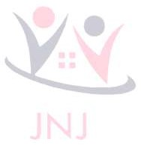
- Parents are requested to encourage your child to use jumbo crayons for enhancing pencil gripping.
- Assignments and project work should be submitted on the first day after winter vacations.

EPL (EXERCISE OF PRACTICAL LIVING): to be practiced daily
- Elementary movements: SCISSOR CUTTING, FOLDING AND UNFOLDING
- Self-care: FACE WASH, BRUSHING, COMBING, TOILET HABITS
- Environmental care: USE OF TRASH BIN, CLEANUP TIME AFTER PLAY.
- SOCIAL SKILLS/PRACTICAL LIFE SKILLS: GREETING ELDERS, USE OF BASIC CURTSY WORDS (THANKYOU, WELCOME, PLEASE), ENCOURAGING GROUP DISCUSSIONS AT HOME.
- Sensory skills: differentiate between hot /cold, sweet/salty, loud/quiet, far/near
- Fine motor skills: make a necklace of ten beads of different shapes and sizes
- Gross motor skills: physical exercises, running, jumping, free outdoor play.
Project work:
- Take a chart paper and paste pictures of five fruits, 5 vegetables, 5 body parts, 5 shapes and 5 colors. (PASTE on separate charts)
- Take a chart paper and paste pictures of big/small, tall/short and more/less objects.
- Make flash cards of letters A-Z.
- Make counting flash cards 1-10.
- Make flash cards with pictures “alif” to “se” tak.

ORAL SKILLS/VERBAL COMMUNICATION
Encourage your ward to answer in complete sentences for language development.
- WHAT IS YOUR NAME? My name is ………………
- HOW ARE YOU? I am fine. Thank you.
- HOW OLD ARE YOU? I am 3 years old.
- WHAT IS YOUR MOTHERS NAME? My Mother’s name is…………

- WHAT IS YOUR FATHERS NAME? My father’s name is………….
- WHAT IS YOUR SCHOOL NAME? The name of my school is Jack N Jill.
- WHERE DO YOU LIVE? I live at …………..
- WHICH COLOUR DO YOU LIKE? I like………….
- WHAT IS YOUR TEACHERS NAME? The name of my class teacher is……………..
- LEARN ANY 5 RHYMES.
- ORAL RECITATION OF A-Z
- ORAL RECITATION OF 1-20
- AWAL KALIMA.
- WHO CREATED US? ALLAH SWT created us.
- WHO IS OUR PROPHET? Prophet Mohammad Rasool SAW is our beloved prophet.
- WHO ARE WE? We are Muslims.
- DUA BEFORE EATING AND FINISHING FOOD?
- WHAT IS OUR RELIGION? Our religion is Islam.

ARTS AND CRAFT
  - THUMB PRINTING ACTIVITY: On a plain paper/craft paper make a caterpillar using your thumb print.
  - HAND PRINTING ACTIVITY: On a plain/craft paper make a butterfly using your hand prints.
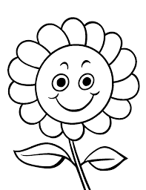
  - Colour: Colour the picture given below (orange to petals, yellow to face, green to leaves , brown to stem.
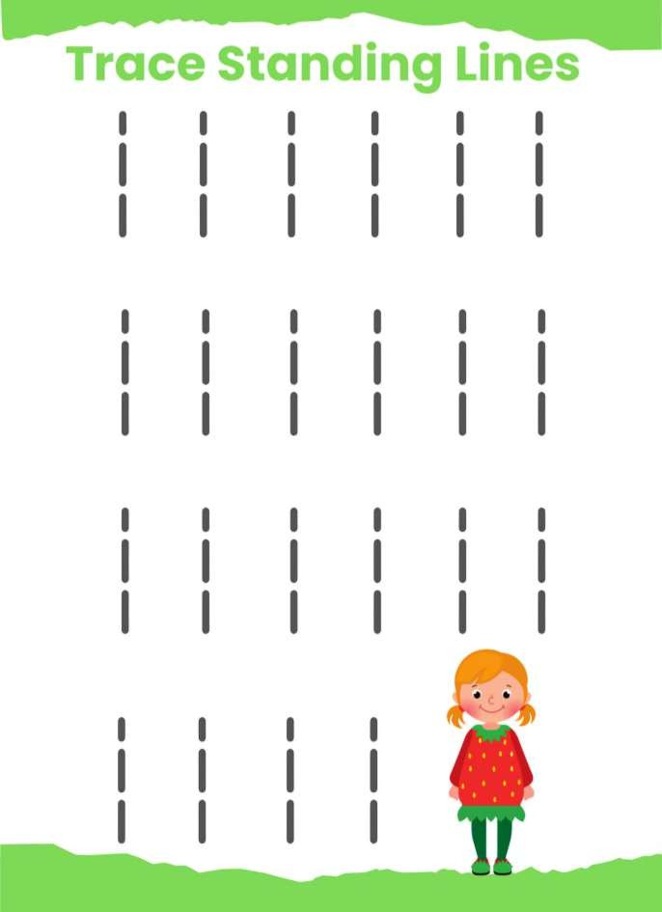
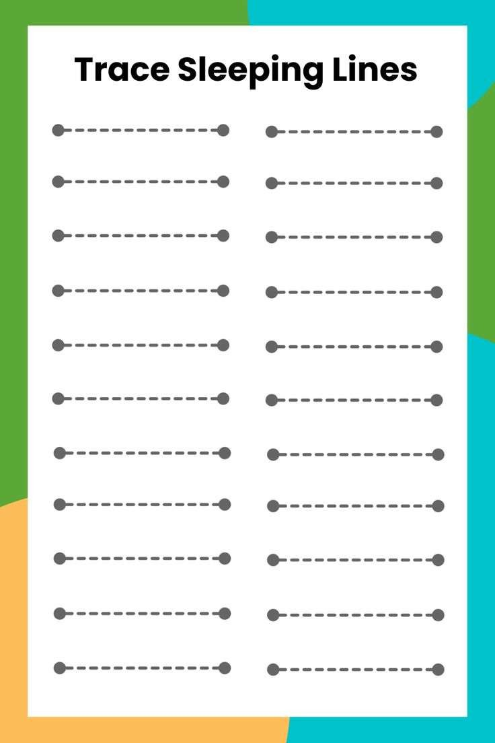
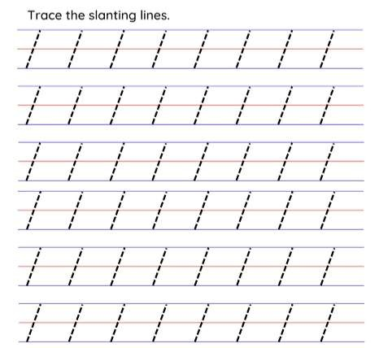
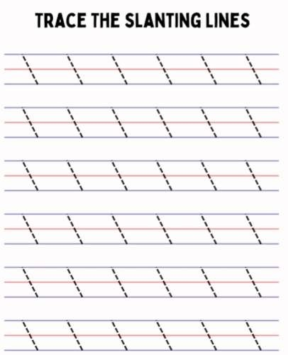
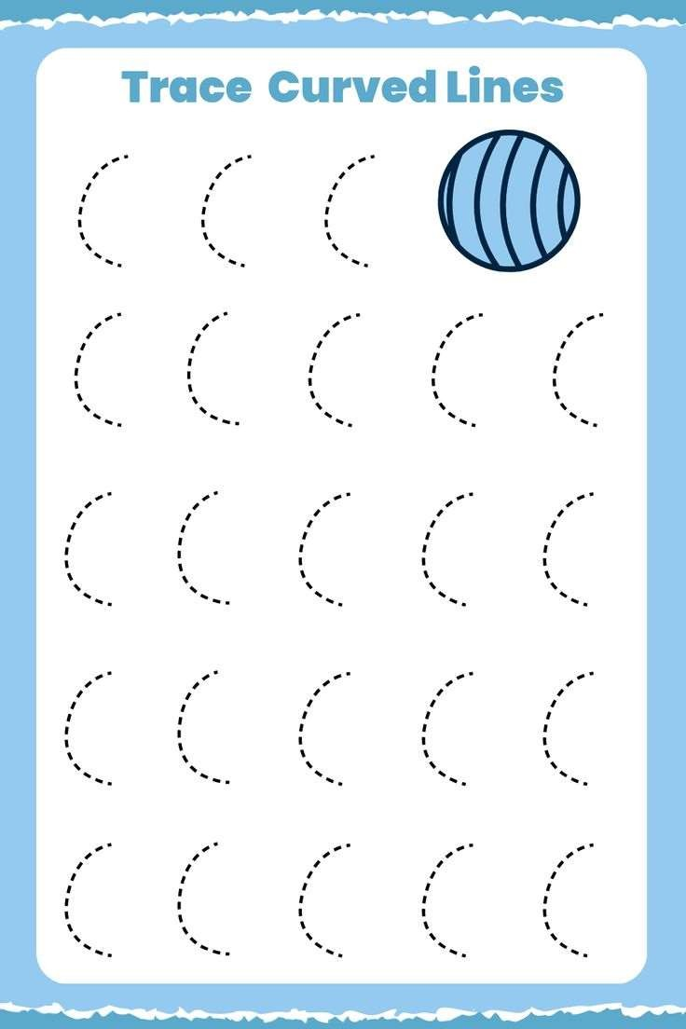
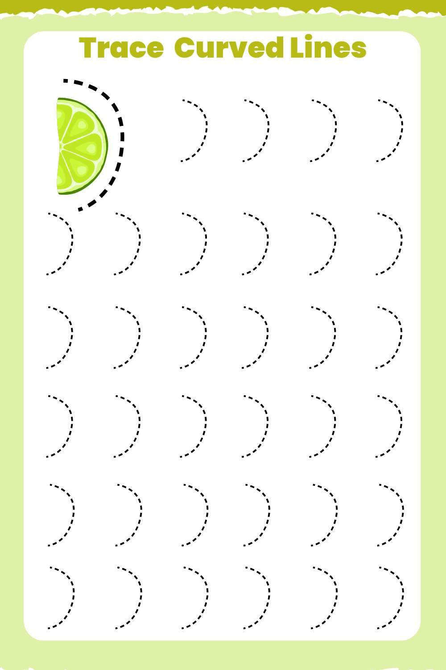
WORKSHEETS (ENGLISH/MATHS/URDU)
