JACK N JILL SCHOOL

SANATNAGAR BY PASS OPP JEEP SHOWROOM

SRINAGAR, 0194 3179576

SESSION 2024-2025

**LKG TERM 1ST**

**ENGLISH:**

* Revision of upper case letters(A-Z)
* Writing of lower case alphabets(a-z)
* Phonetics(A-Z)

**MATH:**

* COUNTING(1-50)
* DODGING(1-50)
* NUMBER NAMES(1-5)
* BACKWARD COUNTING(10-1)
* COUNT & WRITE
* READ & DRAW
* WHAT COMES AFTER
* WHAT COMES BEFORE
* WHAT COMES BETWEEN
* SHAPES
* PRE NUMBER CONCEPT(tall/short, big/small)

**URDU:**

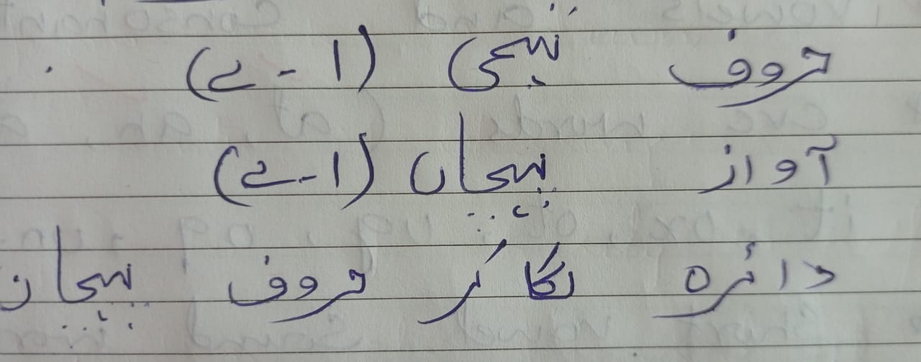

**EVS:**

* MY FAMILY
* MY BODY
* USES OF BODY PARTS
* WHATS IN MY MIND
* LIFE CYCLE OF PLANT
* MY BELONGINGS
* MY UNIFORM
* CLASSROOM OBJECTS
* BEDROOM OBJECTS
* HEALTHY FOOD
* JUNK FOOD
* SUMMER SEASON
* RAINY SEASON
* BIRDS
* DOMESTIC

**EPL: exercises of practical living**

* Opening and closing
* Beading/cutting/folding
* Polishing/folding of clothes
* Blowing nose
* Table manners
* Care of teeth/nails/hair
* Toilet manners + training
* Greeting people
* Use of curtsy words
* Cleanliness of surroundings
* Buttoning of shirt
* Dusting(class cleanup time)
* Care of garden
* Speaking in group
* Helping out
* Wearing of socks /shoes
* Unbuttoning of shirt
* Table manner

**UKG TERM 1ST**

**ENGLISH:**

* REVISION:

1. (A-Z)
2. Vowels and consonants
3. Cvc words:

At

An

Ap

En

It

Ox

Ot

Ug

Og

Un

Ut

1. short vowel sound word
2. long vowel sound words
3. phonetics(A-Z)

**MATH:**

* NUMBERS(1-200)
* NUMBER NAMES(1-50)
* PRE NUMBER CONCEPTS(TALL/SHORT,BIG/SMALL,FULL/EMPTY)
* BACKWARD COUNTING(50-1)
* TABLES OF 2 & 3

**URDU:**

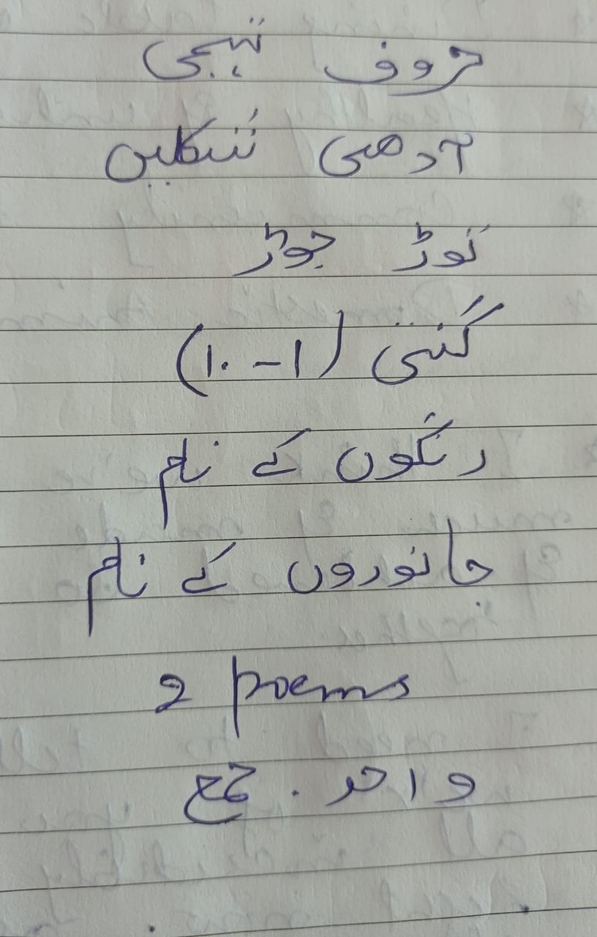

**EVS:**

* MY FAMILY
* MYSELF
* SENSE ORGANS & THEIR FUNCTIONS
* NIGHTWARE DRESSES
* CASUAL WEAR
* KITCHEN ITEMS
* DINING TABLE OBJECTS
* HEALTHY &UNHEALTHY FOOD
* COMMUNITY HELPERS
* DOMESTIC ANIMALS

**EPL: exercises of practical living**

* Opening and closing
* Beading/cutting/folding
* Polishing/folding of clothes
* Blowing nose
* Table manners
* Care of teeth/nails/hair
* Toilet manners + training
* Greeting people
* Use of curtsy words
* Cleanliness of surroundings
* Buttoning of shirt