Jack N Jill School-Budshah Colony Sanat Nagar By-pass

**Winter assignment for Pre Nursery session 2023-2024**

**Project work**

EVS:

* Paste wrappers of junk food on a scrapbook
* Make collage of healthy food items.
* Make different shapes from waste carton, color them with water colours and paste the same on scrapbook.
* Paste 10 vegetables and fruits each on scrap book.

English:

* Make flash cards of alphabets A-Z (laminate them with laminating tape)

Math:

* Make a chart on pre number concept showing (Big/small, Tall/short, Heavy/Light, same/different, More/Less, Far/Near, Hard/soft and fat/thin)
* Make flash cards of number (1-10). (laminate them with laminating tape)

Islamic Teachings:- (Revise the following)

* The correct way of greeting in Islam.
* Who are we? What is our religion?
* Who created us?
* What is the name of our beloved prophet?
* Who should we thank for everything? Who is great?
* Use of Insha Allah, Bismilllah and Alhumdulillah.
* How many times do we offer prayer in a day?

**Note:** Parents are requested to encourage your child to use jumbo crayons for enhancing pencil gripping. All the project work should be done on scrap book. Drill of flash cards should be done on daily basis (Phonetics and numbers).Assignments and project work should be submitted on the first working day after winter vacations.

***Jack N Jill school-Budshah Colony Sanat Nagar By-Pass Srinagar-190005 (0194-2439997)***

Q: Trace the following standing lines using jumbo crayons

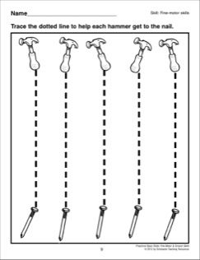

***Jack N Jill school-Budshah Colony Sanat Nagar By-Pass Srinagar-190005 (0194-2439997)***

Q: Trace the following standing lines using jumbo crayons

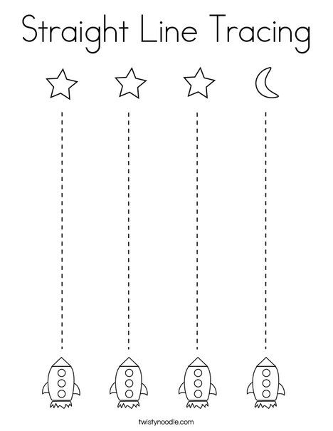

***Jack N Jill school-Budshah Colony Sanat Nagar By-Pass Srinagar-190005 (0194-2439997)***

Q: Trace the following standing lines with index finger using water colors

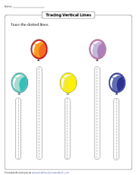

***Jack N Jill school-Budshah Colony Sanat Nagar By-Pass Srinagar-190005 (0194-2439997)***

Q : Trace the following sleeping lines using jumbo crayons

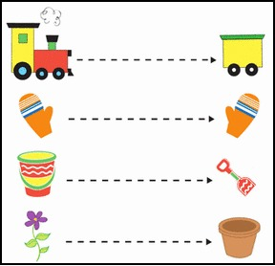

***Jack N Jill school-Budshah Colony Sanat Nagar By-Pass Srinagar-190005 (0194-2439997)***

Q: Trace over the standing lines to match the pictures using jumbo crayon

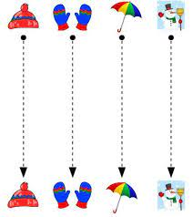

***Jack N Jill school-Budshah Colony Sanat Nagar By-Pass Srinagar-190005 (0194-2439997)***

Q: Trace the following sleeping lines using jumbo crayons

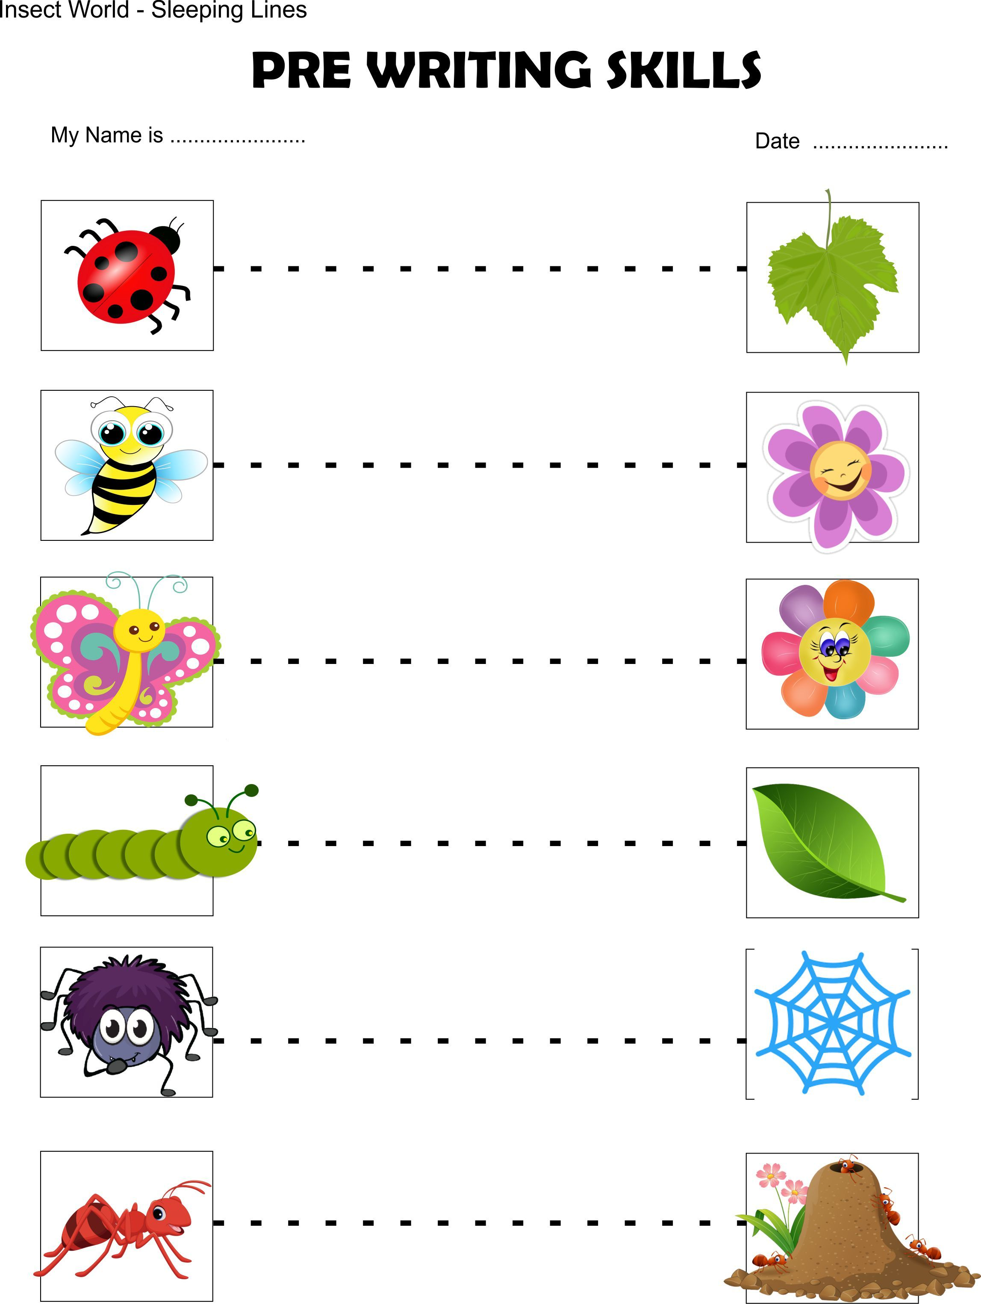

***Jack N Jill school-Budshah Colony Sanat Nagar By-Pass Srinagar-190005 (0194-2439997)***

Q: Trace the following sleeping lines using jumbo crayons

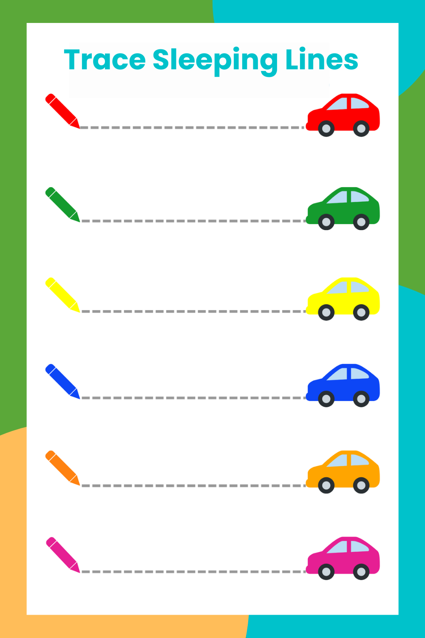

***Jack N Jill school-Budshah Colony Sanat Nagar By-Pass Srinagar-190005 (0194-2439997)***

Q: Take the spiders to their webs by using jumbo crayons

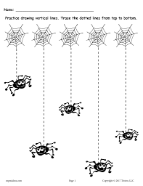

***Jack N Jill school-Budshah Colony Sanat Nagar By-Pass Srinagar-190005 (0194-2439997)***

Q: Trace the following patterns using jumbo crayons

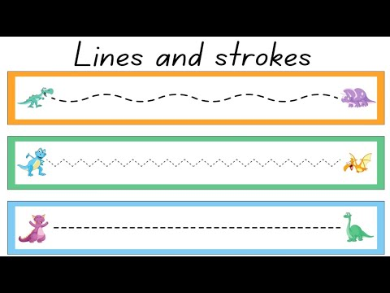

Q: Take the girls to their food from bottom to top

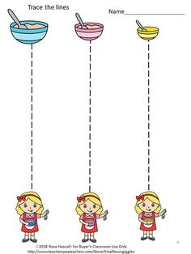

***Jack N Jill school-Budshah Colony Sanat Nagar By-Pass Srinagar-190005 (0194-2439997)***

Q: Trace the following dotted lines from right to left by using jumbo crayons

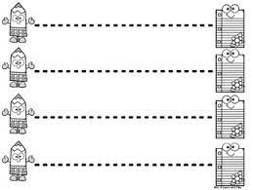

Q: Trace the following sleeping lines by using jumbo crayons

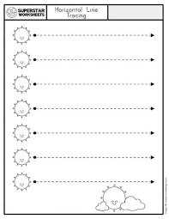

***Jack N Jill school-Budshah Colony Sanat Nagar By-Pass Srinagar-190005 (0194-2439997)***

Q: Trace the following sleeping lines using jumbo crayons

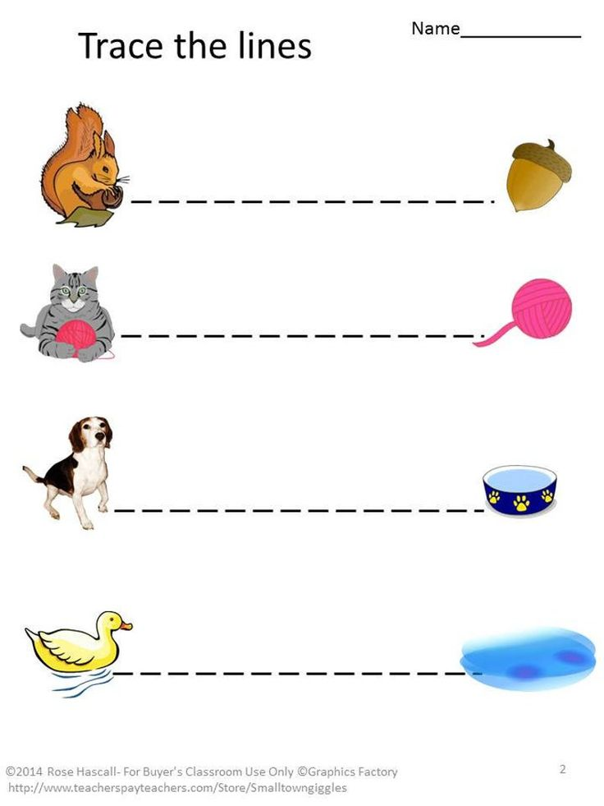

***Jack N Jill school-Budshah Colony Sanat Nagar By-Pass Srinagar-190005 (0194-2439997)***

Q: Trace the dotted lines from left to right

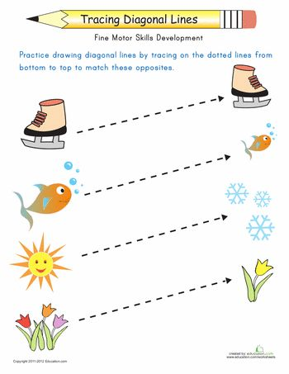

***Jack N Jill school-Budshah Colony Sanat Nagar By-Pass Srinagar-190005 (0194-2439997)***

Q: Trace the following dotted lines from right to left by using crayons

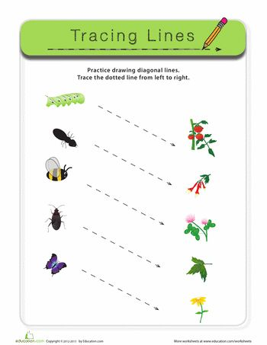

***Jack N Jill school-Budshah Colony Sanat Nagar By-Pass Srinagar-190005 (0194-2439997)***

Q: Trace the following lines by using jumbo crayons

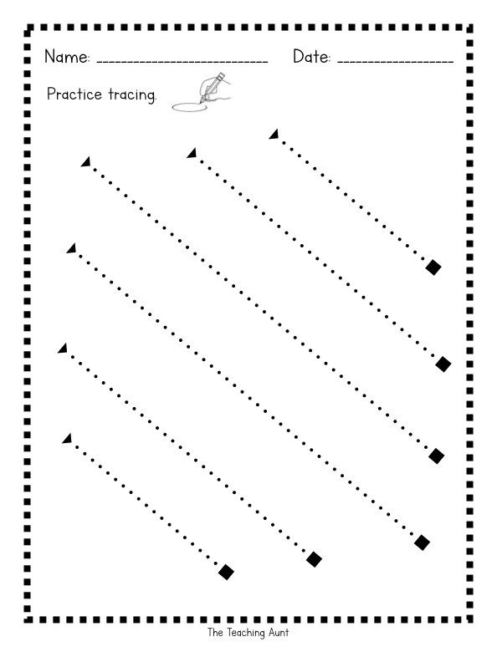

***Jack N Jill school-Budshah Colony Sanat Nagar By-Pass Srinagar-190005 (0194-2439997)***

Q: Trace the following slanting lines using jumbo crayons

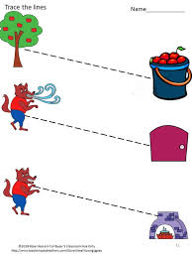

***Jack N Jill school-Budshah Colony Sanat Nagar By-Pass Srinagar-190005 (0194-2439997)***

Q: Assist the car in reaching home by tracing following road lines.

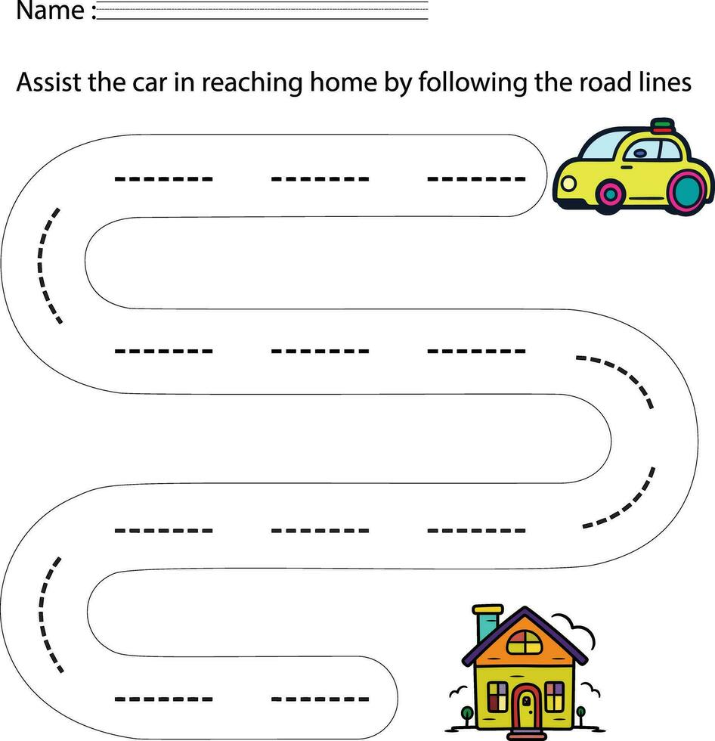

***Jack N Jill school-Budshah Colony Sanat Nagar By-Pass Srinagar-190005 (0194-2439997)***

Q: Help the bunny to reach the carrot by using jumbo crayon

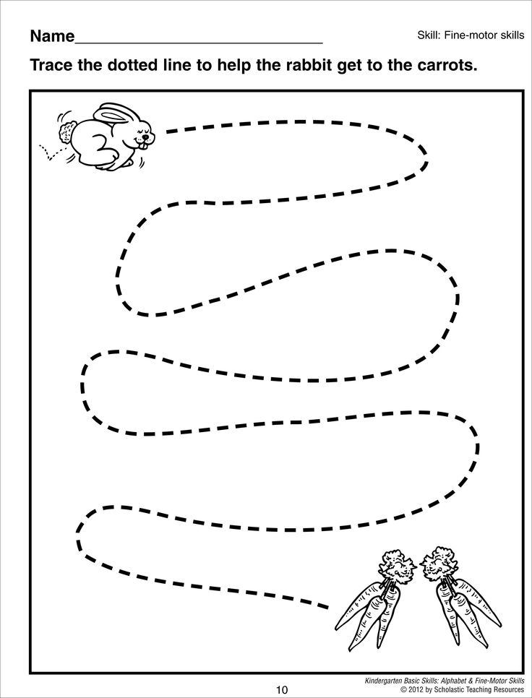

***Jack N Jill school-Budshah Colony Sanat Nagar By-Pass Srinagar-190005 (0194-2439997)***

Q: Assist the following insects to reach their respective houses by using jumbo crayons

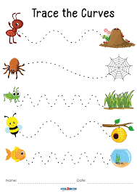

***Jack N Jill school-Budshah Colony Sanat Nagar By-Pass Srinagar-190005 (0194-2439997)***

Q: Trace the following dotted lines by using jumbo crayons

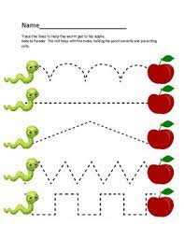

***Jack N Jill school-Budshah Colony Sanat Nagar By-Pass Srinagar-190005 (0194-2439997)***

Q: Trace the following curves using jumbo crayons

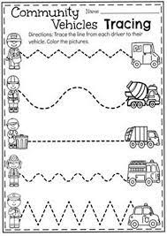

***Jack N Jill school-Budshah Colony Sanat Nagar By-Pass Srinagar-190005 (0194-2439997)***

Q: Trace the following curves using jumbo crayons

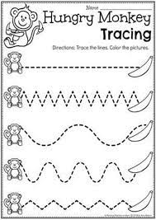 I

n 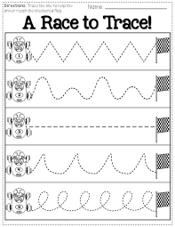

***Jack N Jill school-Budshah Colony Sanat Nagar By-Pass Srinagar-190005 (0194-2439997)***

Q: Trace the following lines by using jumbo crayons

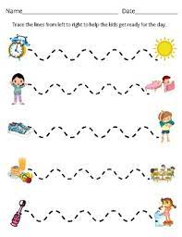

Q: Trace the following patterns by using index finger

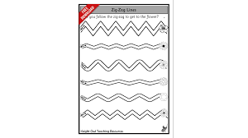

***Jack N Jill school-Budshah Colony Sanat Nagar By-Pass Srinagar-190005 (0194-2439997)***

Q: Trace the following patterns by using index finger

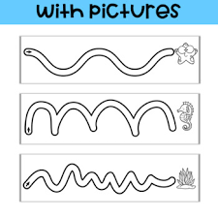

Q: Trace the following curves by using jumbo crayons

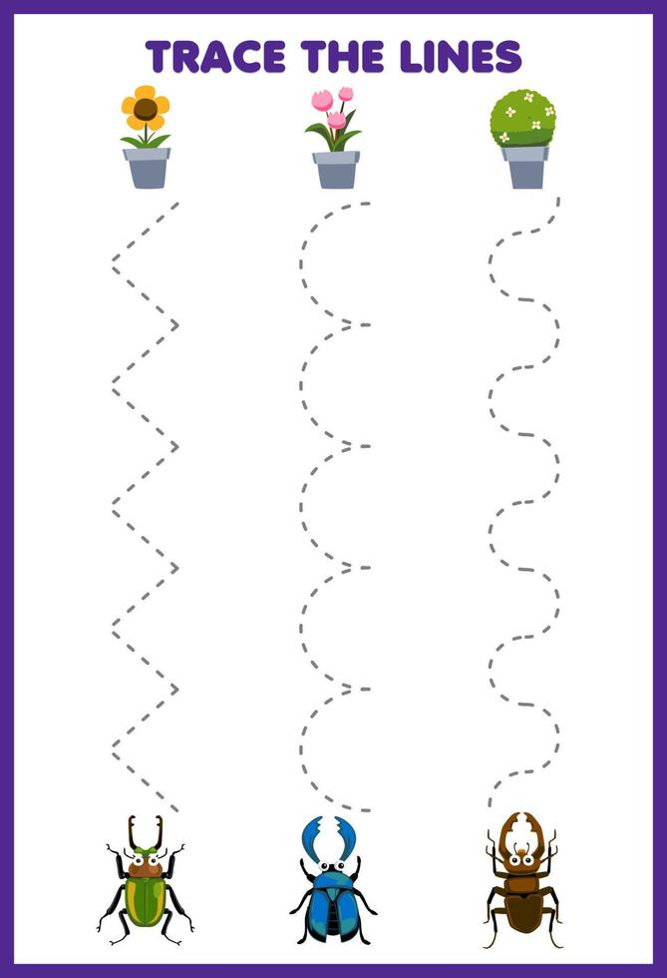

***Jack N Jill school-Budshah Colony Sanat Nagar By-Pass Srinagar-190005 (0194-2439997)***

Q: Trace the following slanting lines by using jumbo crayons



***Jack N Jill school-Budshah Colony Sanat Nagar By-Pass Srinagar-190005 (0194-2439997)***

Q: Trace the following lines using jumbo crayons

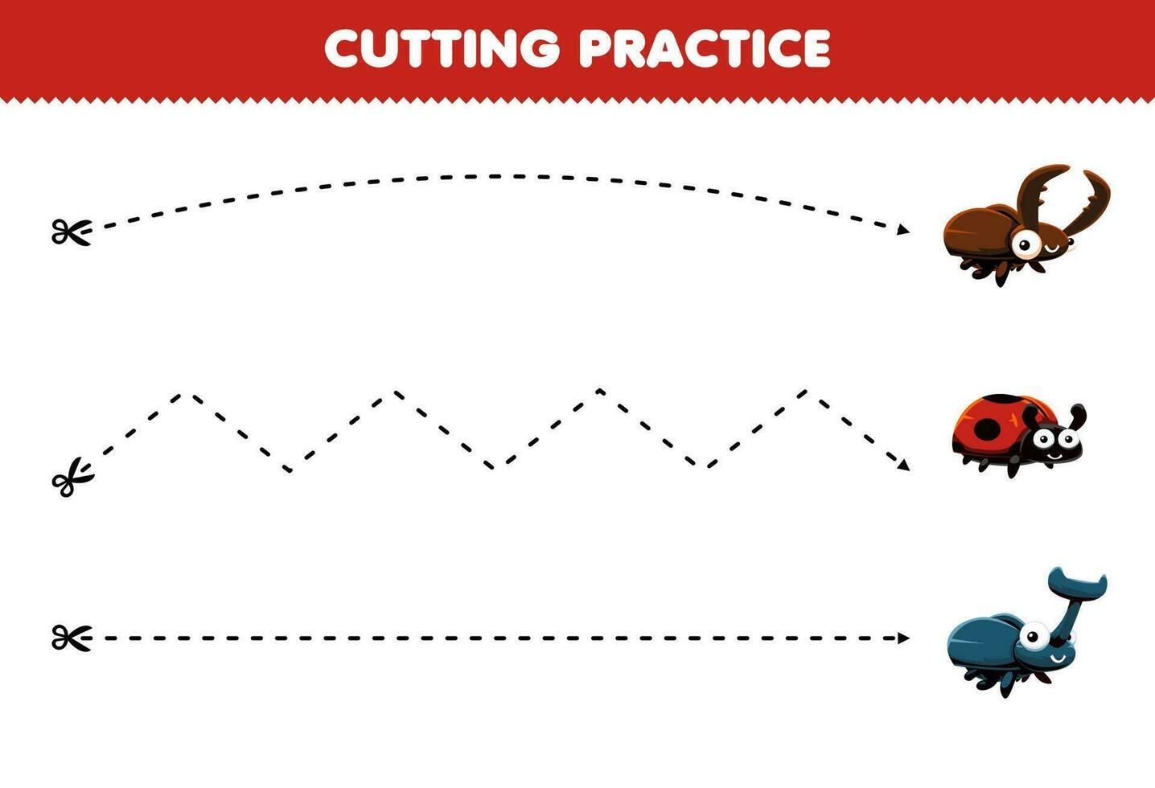

Q: Match the following pictures with their shadows

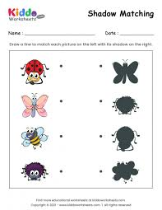



***Jack N Jill school-Budshah Colony Sanat Nagar By-Pass Srinagar-190005 (0194-2439997)***

Q: Trace the following curves by using jumbo crayons

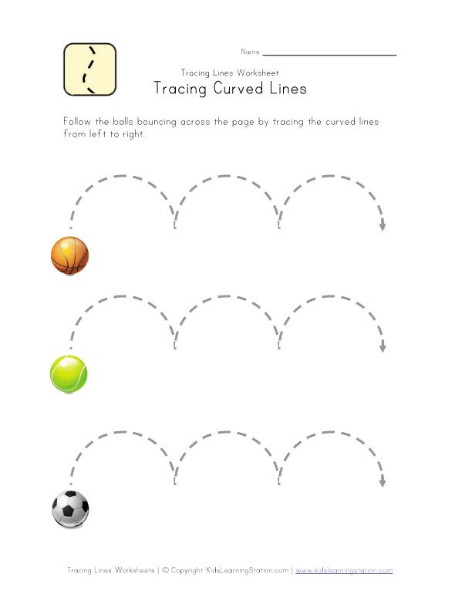

Q: color the apple by doing finger printing



***Jack N Jill school-Budshah Colony Sanat Nagar By-Pass Srinagar-190005 (0194-2439997)***

Q: color the pictures and match them with their corresponding letters

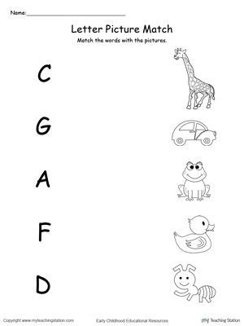

***Jack N Jill school-Budshah Colony Sanat Nagar By-Pass Srinagar-190005 (0194-2439997)***

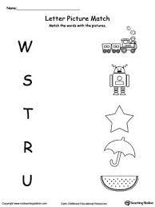

***Jack N Jill school-Budshah Colony Sanat Nagar By-Pass Srinagar-190005 (0194-2439997)***

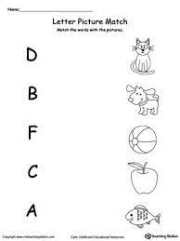

***Jack N Jill school-Budshah Colony Sanat Nagar By-Pass Srinagar-190005 (0194-2439997)***

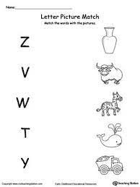

***Jack N Jill school-Budshah Colony Sanat Nagar By-Pass Srinagar-190005 (0194-2439997)***

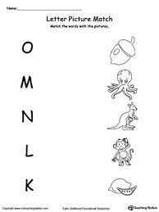

***Jack N Jill school-Budshah Colony Sanat Nagar By-Pass Srinagar-190005 (0194-2439997)***

Q: cut the below picture and paste them on a scrap book accordingly

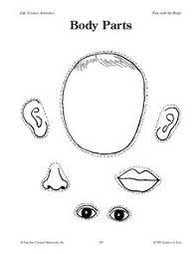

***Jack N Jill school-Budshah Colony Sanat Nagar By-Pass Srinagar-190005 (0194-2439997)***

Q: Create your own body parts cube- color, cut and glue

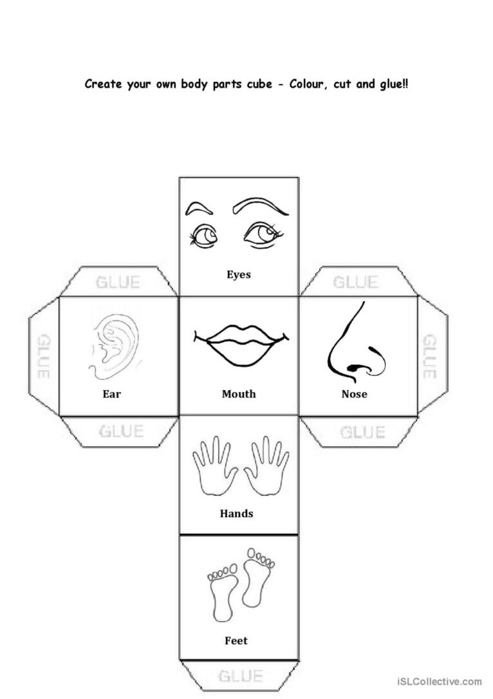

***Jack N Jill school-Budshah Colony Sanat Nagar By-Pass Srinagar-190005 (0194-2439997)***

Q: identify and color the below fruits accordingly

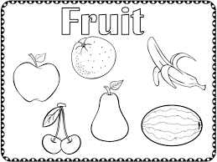

***Jack N Jill school-Budshah Colony Sanat Nagar By-Pass Srinagar-190005 (0194-2439997)***

Q: Identify and colour the below vegetables accordingly

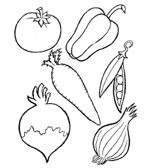

***Jack N Jill school-Budshah Colony Sanat Nagar By-Pass Srinagar-190005 (0194-2439997)***

***Q: Paste the pictures of your family members in the given below family tree***

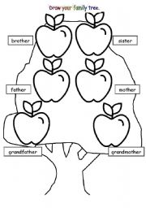

***Jack N Jill school-Budshah Colony Sanat Nagar By-Pass Srinagar-190005 (0194-2439997)***

***Q: Teach your ward about unsafe touches as mentioned below***



***Q: Colour the private parts with red colour and safe body touches with green colour***

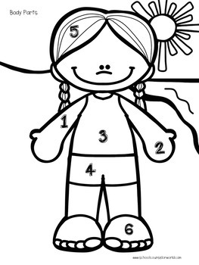

***Jack N Jill school-Budshah Colony Sanat Nagar By-Pass Srinagar-190005 (0194-2439997)***

***Q: Colour the gender you belong to.***

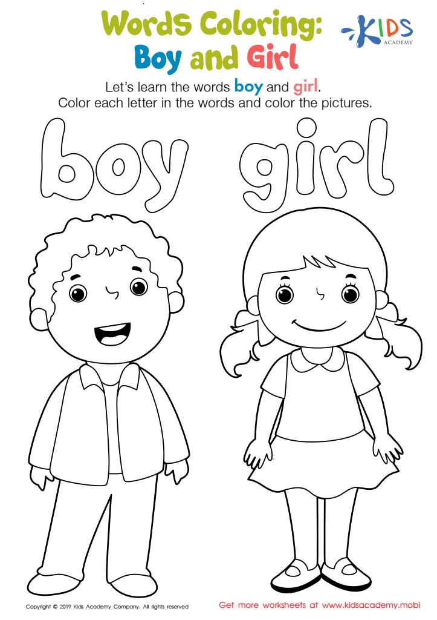

***Jack N Jill school-Budshah Colony Sanat Nagar By-Pass Srinagar-190005 (0194-2439997)***

Q: Identify and draw a line from the number on the left to the matching number on the right. And color the number on the left

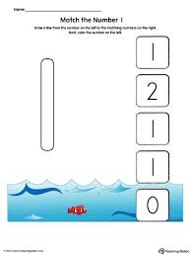

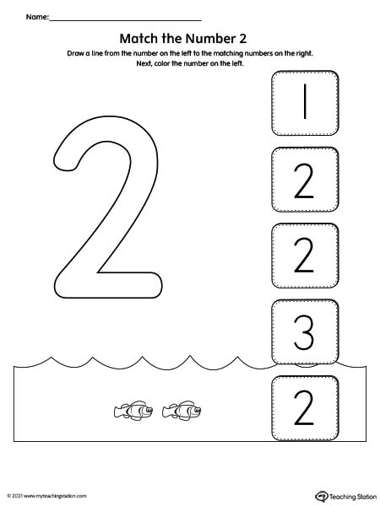

***Jack N Jill school-Budshah Colony Sanat Nagar By-Pass Srinagar-190005 (0194-2439997)***

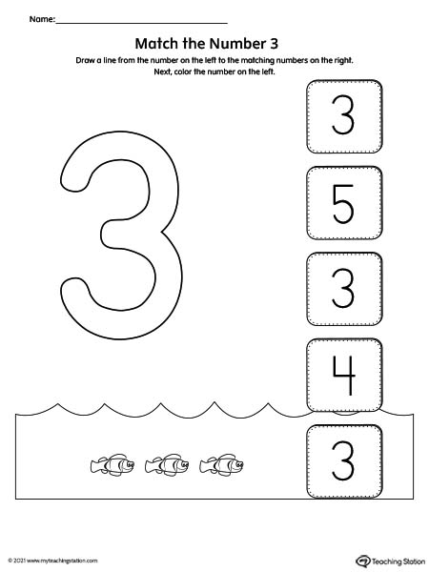

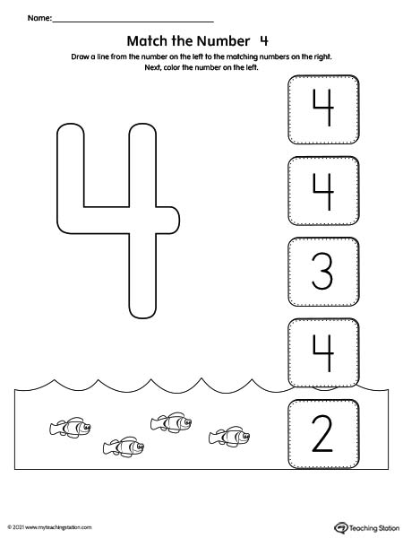

***Jack N Jill school-Budshah Colony Sanat Nagar By-Pass Srinagar-190005 (0194-2439997)***

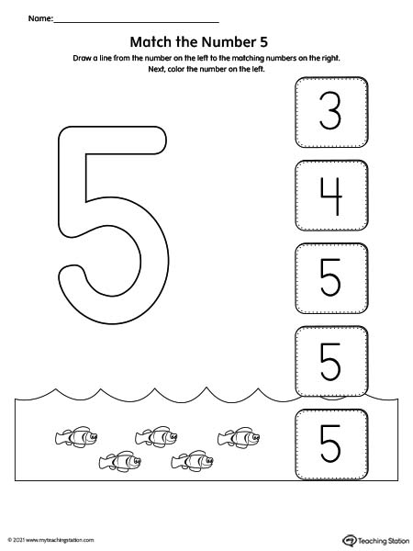

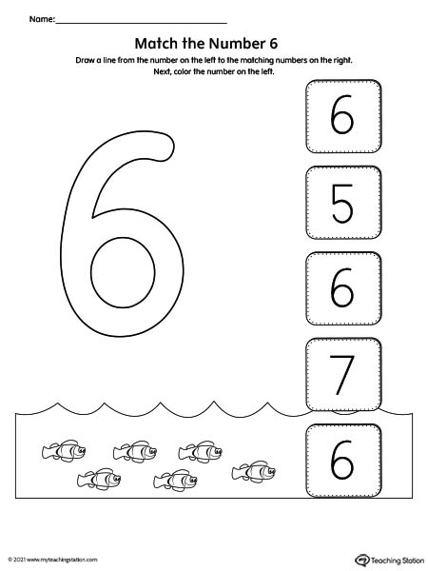

***Jack N Jill school-Budshah Colony Sanat Nagar By-Pass Srinagar-190005 (0194-2439997)***

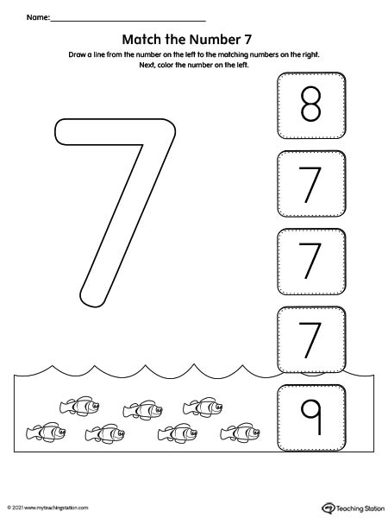

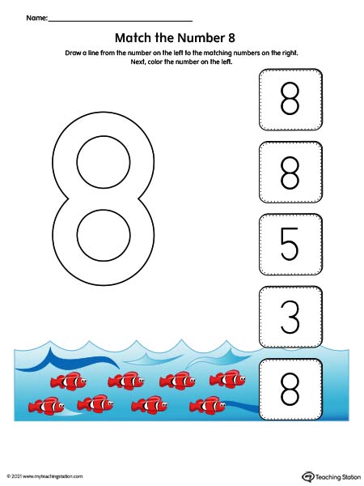

***Jack N Jill school-Budshah Colony Sanat Nagar By-Pass Srinagar-190005 (0194-2439997)***

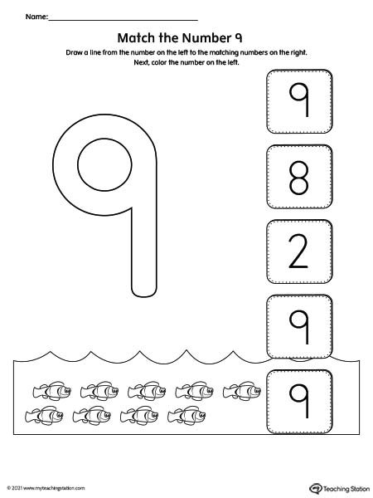

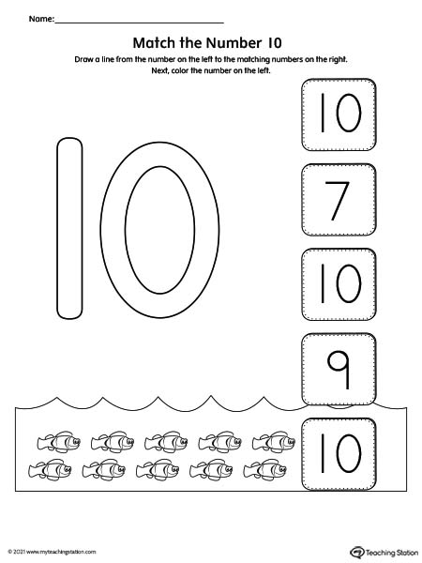

***Jack N Jill school-Budshah Colony Sanat Nagar By-Pass Srinagar-190005 (0194-2439997)***

Q: Identify, count and go over the strokes to match the numbers

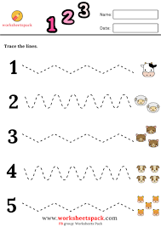

***Jack N Jill school-Budshah Colony Sanat Nagar By-Pass Srinagar-190005 (0194-2439997)***

Q: count and match the numbers with their corresponding dots

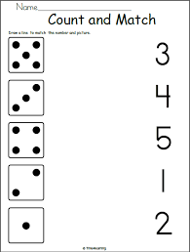

***Jack N Jill school-Budshah Colony Sanat Nagar By-Pass Srinagar-190005 (0194-2439997)***

Q: count and match the numbers

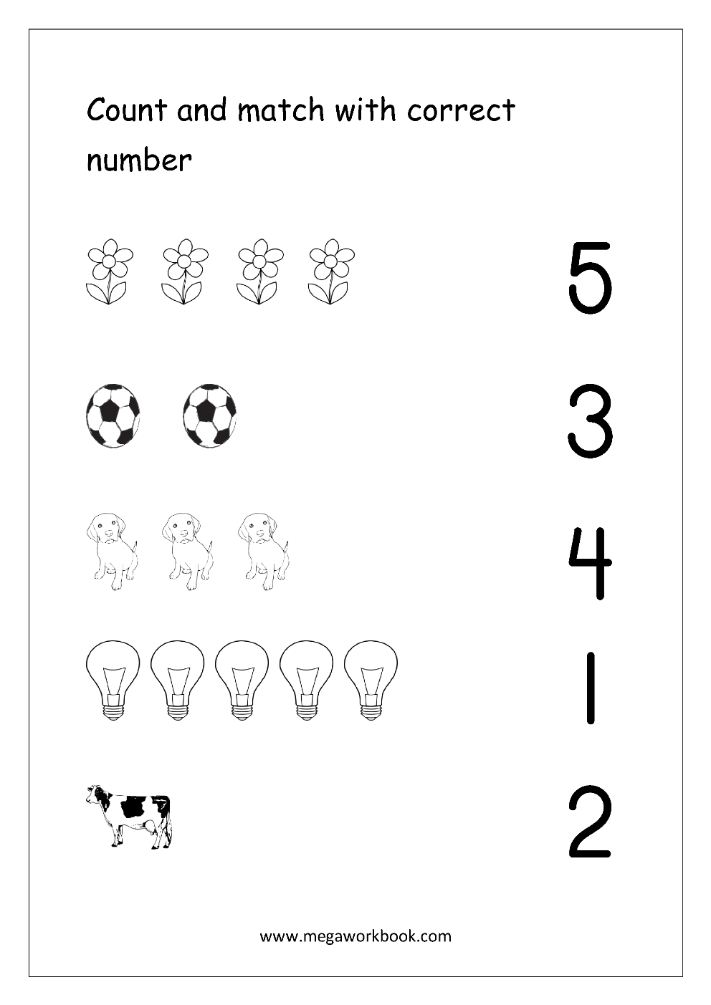

***Jack N Jill school-Budshah Colony Sanat Nagar By-Pass Srinagar-190005 (0194-2439997)***

Q: Colour the numbers as per the colour code given below.

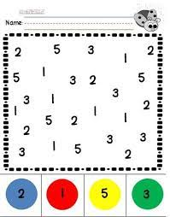

Blue red yellow green

***Jack N Jill school-Budshah Colony Sanat Nagar By-Pass Srinagar-190005 (0194-2439997)***

Q: Identify and match the shapes

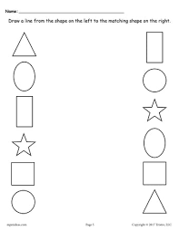

***Jack N Jill school-Budshah Colony Sanat Nagar By-Pass Srinagar-190005 (0194-2439997)***

Q: Colour only triangle’s

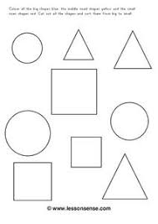

***Jack N Jill school-Budshah Colony Sanat Nagar By-Pass Srinagar-190005 (0194-2439997)***

Q: Trace the circles and paste cotton on them to make a snowman

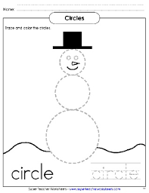

***Jack N Jill school-Budshah Colony Sanat Nagar By-Pass Srinagar-190005 (0194-2439997)***

Q: Trace the circles and colour them with different colors

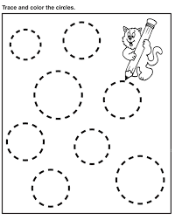

***Jack N Jill school-Budshah Colony Sanat Nagar By-Pass Srinagar-190005 (0194-2439997)***

Q: Identify and match the following shapes

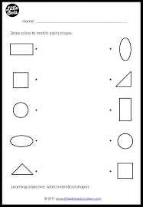

***Jack N Jill school-Budshah Colony Sanat Nagar By-Pass Srinagar-190005 (0194-2439997)***

Q: Color the tall animal

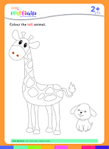

Q: Color the tall object and circle the small one

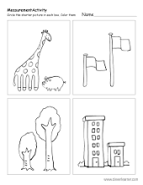

***Jack N Jill school-Budshah Colony Sanat Nagar By-Pass Srinagar-190005 (0194-2439997)***

Q: color the big object and circle the small one

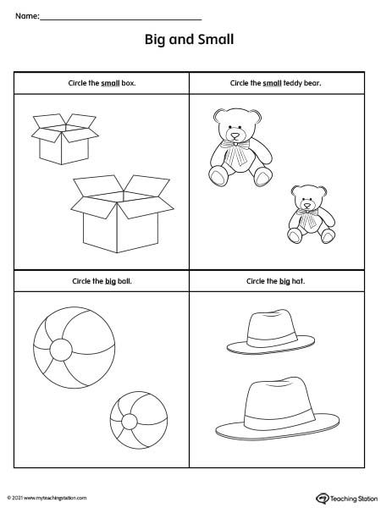

Q: color the set in each row that has more objects than the other set

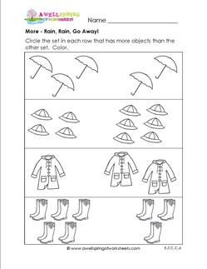

***Jack N Jill school-Budshah Colony Sanat Nagar By-Pass Srinagar-190005 (0194-2439997)***

Q: in each row, color the group that has less

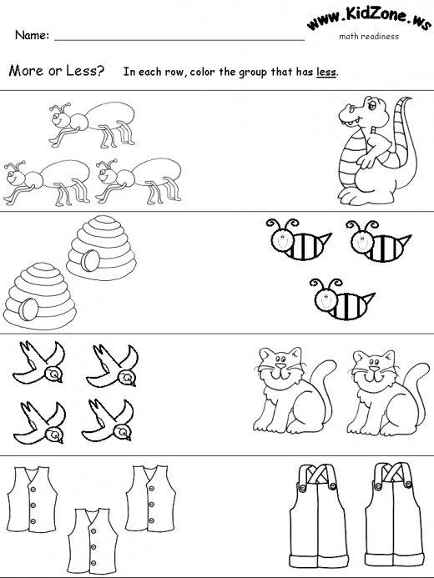

Q: circle the animal that is nearest to the tree

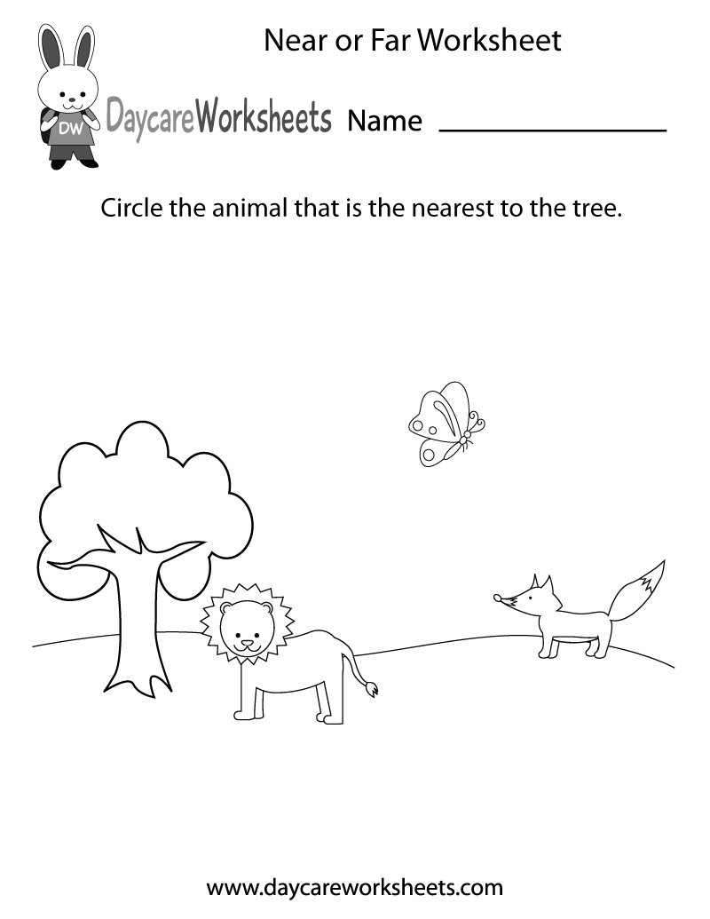

***Jack N Jill school-Budshah Colony Sanat Nagar By-Pass Srinagar-190005 (0194-2439997)***

Q: color only fat person

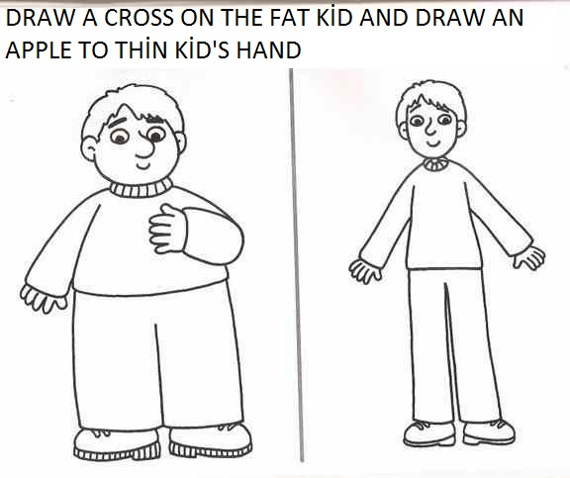

Q: color only thin person



***Best of Luck***

***Jack N Jill school-Budshah Colony Sanat Nagar By-Pass Srinagar-190005 (0194-2439997)***