Jack N Jill, Sanatnagar
WINTER ASSIGNMENT
LKG
“INSTRUCTIONS”
- Kindly make your ward practice the winter work on separate notebooks.
- Your are requested to send the winter work notebooks with your wards when the school reopens.
- Don’t forget to send the pictures of your ward during activities.
- Help your wards to do reading of the words that are attached in the english section of the assignment.

Subject: English

Q1: Converse in English :
To develop the communication skills of your children in English ensure to converse small sentences in English only.

Teachers are trying to encourage the children to use simple sentences, words and phrases like:
- May I come in Ma’am?
- May I drink water?
- May I go to the toilet?
- I am feeling thirsty.
- I am feeling hungry.
- Please give me a pen.
- Please give me an eraser, etc.

Revise the above sentences during this winter break.

Children can also be encouraged to use simple words and sentences at home like-
- Mom, I am hungry please give me something to eat.
- Please give me a glass of water.
- Please open/shut the door.
- Please trim my nails.
- Can I watch TV?
- I am feeling sleepy.

Q2: Use Magical words.
Excuse me, Sorry, Thank you, Please.
Q3: Learn to wish “Good Morning”, “Good Afternoon” and “Good evening”.

Q4: Reading of the following sight words:

- Is
- The
- I

- Me
- My
- To
- Go
- Of
- At
- He
- She
- In
- It
- A
- And

Q5: Reading of vowels and consonants with their phonic sounds.

Vowels: a, e, I, o, u
Consonants: b, c, d, f, g, h, j, k, l, m, n, p, q, r, s, t, v, w, x, y, z

Note: You can also refer to youtube video for the better understanding of your child.

Q6: Reading of the following three letter words:

- Bat
- Cat
- Can
- Bed
- Bot
- Cot
- Cup
- But
- Hen
- Hat
- Hut
- Hop
- Jug
- Jet
- Ket
- Mat
- Man
- Mop
- Mug
- Pup
- Pat
- Pin
- Pop
- Rat
- Run
- Sip
- Sat
- Sun
- Wet
- Zip

Q6: Buy any Moral story-books for children and ensure to narrate one story daily to your child.

“Written Work”
Revise capital letters (A-Z).
Revise phonics (orally).

Subject: Mathematics

Learning time-
Memorize your Mother’s and Father’s mobile numbers.
Craft time:
Cut out the basic shapes like Circle, Rectangle, Square and Triangle from the glazed/craft papers and paste it on a chart. You can also decorate them using googly eyes.

“Written Work”
Revise counting 1-20.
Revise backward counting 10-0

Subject: EVS

Healthy living:

Emphasize your child to spend atleast half-an-hour (30 mins) every morning before breakfast doing these exercises:
Jumping, Running, Hop, Practice Aerobics, Simple yoga, Exercises, Bending and then touching feet, Swimming exercise, tapping knees with hands etc.
Q1: Make a texture chart and paste different strips of different clothes like cotton, silk, wool, satin etc on it and also paste a strip of sand paper on it.

Q2: Paste pictures of 5 fruits, vegetables, pet animals, wild animals, water animals, insects on separate charts.

Q3: Partition the chart in two halves and paste pictures of junk food and healthy food on it.
Subject: Urdu

Q1: Make flash cards of haroof-e-tahaji.
Q2: On a chart, make a nest and paste dried grass, twigs and crumbled egg shells on it. Also make a sparrow on it and make your child understand about the importance of nests for birds.

“Written work”
Q1: Revision of Haroof-e-tahaji.
Q2: Say aloud haroofs in between and make your child to write them.
Subject: Art
Q1: Draw a snowman, cap and socks on a craft paper then cut these thing out and decorate them using cotton, google eyes and sticker stones.
Q2: Make a house using matchsticks on a drawing book.
Q3: On a drawing book, give thumb impressions of your family. Then name as Mummy, Daddy, Me etc.
Q4: Make a DIY Pencil topper.
It’s time to be creative and show your art and craft skills, by making a cute pencil topper for your pencil-
- Choose the pencil topper shape. Think about what kind of pencil topper you want to make- a flower, a star, an animal, or even a boy or girl’s face.
- Cut out the shapes drawn on craft foam (2 in number).
- Glue them together.
- Mark the center and punch a hole.
- Slide the topper to the top of a pencil and decorate.

“WORKSHEETS”
Subject: English

Q1: Match the pictures with letters.

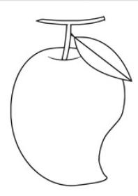
D

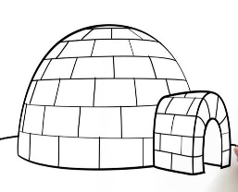
M

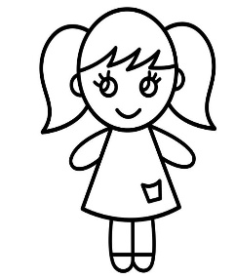
I

Q2: Circle the first letter for the given pictures.


C T M L

H V F O

R S Z U

Subject: Mathematics

I can count and match.
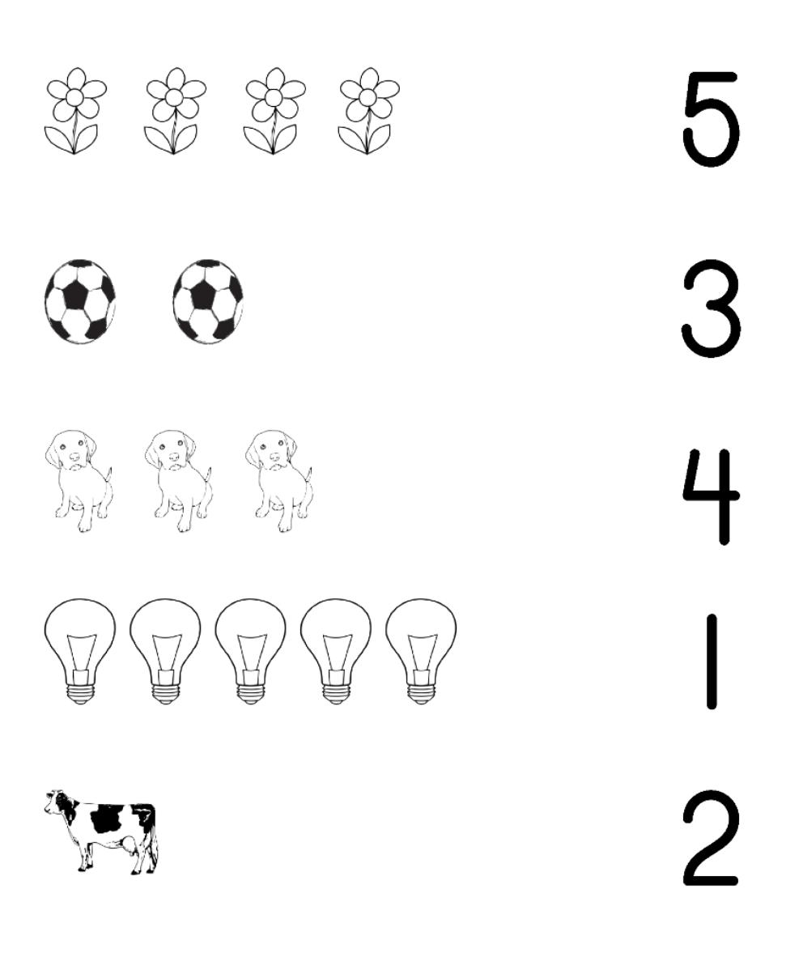

See the numbers and paste small colourful bindis accordingly inside the tortoise shells.

- 6
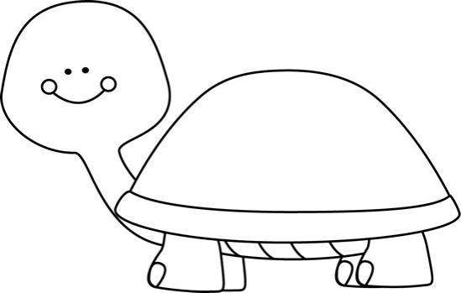
- 10

- 3

