Jack N Jill, Sanatnagar
WINTER ASSIGNMENT
UKG
“INSTRUCTIONS”

- Kindly make your ward practice the winter work on notebooks.
- You are requested to send the winter work notebooks with your ward on the first day when the school reopens after winter break.
- Don’t forget to send the pictures of your ward during winter activities.
- Help your child to do reading of the words mentioned down in the English assignment section.

Subject: English
Q1: Communication skills have a significant impact on a child’s personality development. Nowadays, kids spent astounding amount of time on their electronic devices and with this shift, they are losing their skills in how to communicate their needs- with their own voices. Improving communication skills in children of all ages today could benefit generations to come, salvaging the power of verbal communication in world.
Start with, using these small sentences and encourage the child to speak in English for their language development. Like-
- How are you? I am fine/good.
- May I get something to eat?
- What do you like to eat?
- Excuse me!
- Please, open /close the door.
- I have finished my work/food.
- I want to go to the market etc.

Q2: Reading of vowels and consonants with their appropriate sound.
Vowels: A, E, I, O, U
Consonants: B, C, D, F, G, H, J, K, L, M, N, P, Q, R, S, T, V, W, X, Y, Z

Q3: Reading of words with vowel sounds.
Short “a” vowel sound

- Man
- Mat
- Bag
- Cat
- Tap
- Bat
- Cap
- Fan
- Ram

Short “e” vowel sound

  - Jet
  - Web
  - Den
  - Net
  - Leg
  - Hen
  - Wet
  - Bed

  - Ten

Short “i” vowel sound

- Zip
- Bin
- Sit
- Tin
- Ice
- Pin
- Wig
- Fin
- Nib

Short “o” vowel sound

- Hot
- Dog
- Mop
- Ox
- Cot
- Box
- Pot
- Top
- Rod

Short “u” vowel sound

  - Hut
  - Gun
  - Bum
  - Nut
  - Tub
  - Bus
  - Run
  - Pup

Q4: Phonic drill.

- Am
- An
- As
- At
- Of
- On
- Or
- Me
- He
- We
- Be
- Go
- So
- No
- Us
- Up
- In
- If
- Is
- It
- By
- My

Q5: Tell your child a bedtime story daily.

“Written Work”
Q1: Revise capital alphabets (A-Z).
Q2: Revise small alphabets (a-z).

Subject: Mathematics
Q1: Memorize your father’s and mother’s contact number.
Q2: Memorize the age of youngest member and the eldest member of your family.

“Written Work”
Q1: Revise counting 1-100.
Q2: Revise Backward counting 20-1.
Q3: Revise number names 1-5.

Subject: EVS
Q1: Let’s explore nature by accompanying our grandparents/parents to a morning/evening walk and observe various animals, birds and plants.
- On the walk, collect dry leaves of varied shapes and be creative with them and paste them on a scrapbook.
- Make a small nest with dry twigs, branches etc on a scrapbook.
- Sound boxes- Make with empty fruits cartons, small size boxes filled with different ingredients like mustard seeds, rice, dal, pebbles , big channa etc.

Q2: Draw or paste 5 fruits, vegetables, pet animals, wild animals, water animals, birds and means of transport.

Subject: Urdu
Q1: Make a tree and cut it out. After cutting the tree, draw apples on different craft paper and write Haroof-e-tahaji on those apples. Paste these apples on a tree later.

Q2: Make flash card and write counting 1-10 (ginti) in urdu on it.

“Written Work”
Q1: Revise Haroof-e-tahaji.
Q2: Revise Haroof ki aadhi shakle.

“Activity Work”

- Bird feeder: To inculcate the habit of helping the birds around us, let’s make a bird feeder with the help of a waste water bottle.

- Make a beautiful collage on “How you enjoyed or spend you Winter Vacation?”
(You can paste the photos with your family, playing with your friends and pet, visit to new places, doing different activities etc on a scrapbook.

Family Bonding Time
Spend quality time with your family and help them to-

- Lay the table/Dastarkhwan.

- Assist in the kitchen like giving someone water, putting plates on Dastarkhwan etc.

Play 2 indoor games of your own choice and paste pictures of the same on chart paper.

“Worksheets”
Name: ____________ Class: UKG
Subject: English

Q1: Circle the vowels.

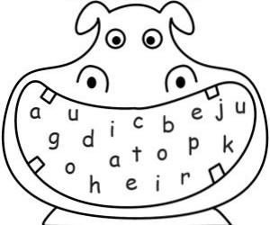

Q2: Change into small letters.

Q _____ P _____

W _____ A _____

E ______ S _____

R ______ D ______

T ______ F ______

Y ______ G ______

U ______ H ______

I ______ J ______

Subject: Mathematics

Q1: Write the missing numbers.
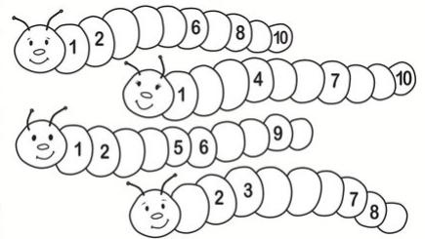

Q2: What comes after, before and between.

After Before
16 ______ ______ 33
44 ______ ______ 4
82 ______ ______ 11
90 ______ _______ 7

Between
22 _______ 24
59 _______ 61
90 _______ 92

